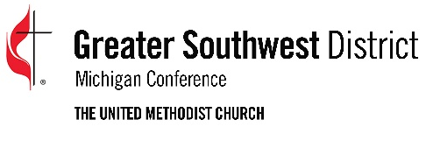
2019-2020 Greater Southwest District
ENGAGE Project Application

Date of Application _________________ Project Begins _______________

Name of Mission or Ministry Project _________________________________________

Phone ________________ Address __________________________________________

City _______________________________________ State________ Zip_____________

Name of Person making application _________________________________________

Phone ________________________ Email ____________________________________
Brief description (100 words or less) of the project:

Does this ministry address the needs and hopes of people in the community? Describe the process you used to determine this.
____________________________________________________________________________
____________________________________________________________________________
____________________________________________________________________________

How are you or your congregation personally willing to invest your very best gifts and abilities to develop this ministry?
____________________________________________________________________________
____________________________________________________________________________
____________________________________________________________________________

List the ministry resources that are currently available and being used:
____________________________________________________________________________
____________________________________________________________________________
____________________________________________________________________________

List other potential assets within the church and among congregation members:
____________________________________________________________________________
____________________________________________________________________________
____________________________________________________________________________

List Potential Partners within your community:
Individuals: ___________________________________________________________________
Businesses: __________________________________________________________________
Associations: _________________________________________________________________
Public Institutions: _____________________________________________________________
Other: _______________________________________________________________________

Please attach responses to the following questions:
- How does your project fulfill the Mission of the United Methodist Church, “make disciples of Jesus Christ for the transformation of the world?” Please give specific examples.

- How does your project engage in ministry with vulnerable and marginalized individuals and communities? Please give specific examples of how your project:
- Respects the inherent dignity and intrinsic worth of all people engaged in the project?
- Transcends boundaries of race class, social status, etc.?
- Engages in both works of mercy and justice?

Please attach the following financial information:
- Proposed budget for project
- Include amount received (or anticipated) from other United Methodist sources
- Amount received (or anticipated) from non-United Methodist sources
- If you envision this project to be ongoing, how do you plan to generate the support necessary to continue?

Please attach the following organizational information, if applicable or available:
- How long has your project been in operation or when do you anticipate it to begin?
- Please attach a roster of the Leadership team for the project

Please attach an Annual Report, brochures or any other publications describing the work of your project.

Return form to: Greater Southwest District
2350 Ring Road North, Suite B
Kalamazoo, MI 49006
-OR-
mnordbrock@michiganumc.org

