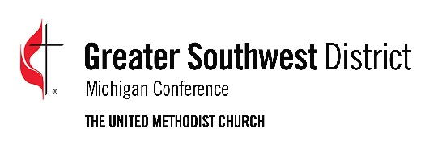
2022 Greater Southwest District
ENGAGE Mission & Ministry Grant Application

Church or Organization Making Request:
Date of Application: Project Begins:
Amount Being Requested:
Name of Mission or Ministry Project:
Phone: Address:
City: State: Zip:
Name of Person making application:
Phone: Email:
Brief description (100 words or less) of the project:

Does this ministry address the needs and hopes of people in the community? Describe the process you used to determine this.

How are you or your congregation personally willing to invest your very best gifts and abilities to develop this ministry?

List the ministry resources that are currently available and being used:

List other potential assets available to support this ministry that are within the church and among congregation members:

List Potential Partners within your community:
Individuals:
Businesses:
Associations:
Public Institutions:
Other:

Please attach responses to the following questions:
- How does your project fulfill the Mission of the United Methodist Church, “make disciples of Jesus Christ for the transformation of the world?” Please give specific examples.

- How does your project engage in ministry with vulnerable and marginalized individuals and communities?
- Please give specific examples of how your project:
-Respects the inherent dignity and intrinsic worth of all people engaged in the project?
-Transcends boundaries of race class, social status, etc.?
-Engages in both works of mercy and justice?

Please attach the following financial information:
- Proposed budget for project
- Include amount received ( or anticipated) from other United Methodist sources
- Amount received (or anticipated) from non-United Methodist sources
- If you envision this project to be ongoing, how do you plan to generate the support necessary to continue?

Please attach an Annual Report, brochures or any other publications describing the work of your project.

Return form to: Greater Southwest District
2350 Ring Road North, Suite B
Kalamazoo, MI 49006
-OR-
mnordbrock@michiganumc.org

