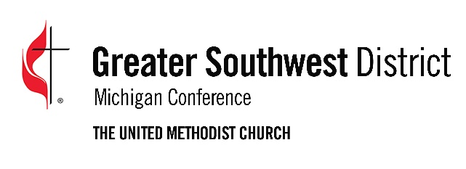
2023 Greater Southwest District
Fresh Expressions Grant Application

The Fresh Expressions grant is designed to provide start-up funds for outreach efforts focused on reaching new people.
Church or Organization Making Request:
Phone: Address:
City: State: Zip:
Name of Project:
Date of Application: Project Begins:
Amount of Request:
Name of Person making application:
Phone: Email:
Please write a brief description of the project including who you are trying to reach out to with this effort and results you anticipate:

