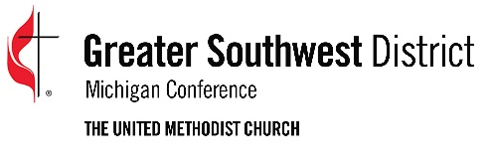
2023 Greater Southwest District
Person in Mission Scholarship Application

The Greater Southwest District awards Person in Mission Scholarships for up to $500 (depending upon funds available). A strong preference in the selection process is given to persons going on their first mission trip. The trip must be sponsored by a church or organization affiliated with The United Methodist Church and going to a project hosted by a church or organization affiliated with The United Methodist Church. The signature of a pastor, youth or young adult leader is required on this application. Please return applications by August 1 for fall trips, by December 1 for winter/spring trips and by May 1 for summer trips.

NAME:

ADDRESS:

CITY: STATE: ZIP:

PHONE: EMAIL:

HOME CHURCH:

UNITED METHODIST CHURCH OR ORGANIZATION SPONSORING THE TRIP:

LOCATION OF THE TRIP: TRIP DATES:

UNITED METHODIST CHURCH OR ORGANIZATION HOSTING THE TRIP:

AMOUNT REQUESTED (up to $500):
IS THIS YOUR FIRST MISSION TRIP? Yes No

SIGNATURE: ____________________________________ DATE:

is an active participant in our ministry. I support their participation in this mission work team and I recommend that they receive scholarship assistance from the Greater Southwest District.

SIGNATURE ____________________________________ DATE:
(UM Organization Representative)

Return form to: Greater Southwest District
2350 Ring Road North, Suite B
Kalamazoo, MI 49006
-OR-
mnordbrock@michiganumc.org

